How to Be an Ally Handbook

Activity: Personal reflection

Think of a time when someone stood up for you or when you witnessed someone standing up for another person.
- How did that make you feel?
- How did it have an impact on your life?
- What does allyship mean to you?
Notes:

What does it mean to be an ally?

Allyship
An ally is someone who uses their power and privilege in society to advocate for marginalized people to empower themselves. Allyship is not about giving someone preferential treatment; it’s about recognizing that we all have some power to support others. However, some people have more power to share than others. To be an ally, you don’t have to share similar diversity dimensions like race, age, or gender. You don’t even have to fully understand what oppression feels like. Rather, it’s actively taking on the struggle as your own, not the experience.

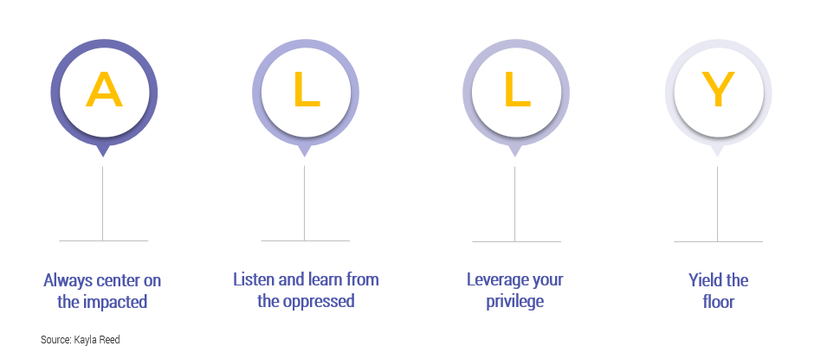

Notes:

Activity: To be or not to be

Complete the following statements:

I care about allyship because…

I am hesitant to be an ally because…

Learn about the implications of social structures and systems of inequality

Social structures
Social structures refer to patterns of relationships, interactions, and constructed norms that make up the larger society. For example, class, gender, race, and ability are some common social structures. While some structures are not visible, most if not all influence the dimensions of an individual’s life. They produce and maintain systems of inequality like racism and sexism, to name a few.

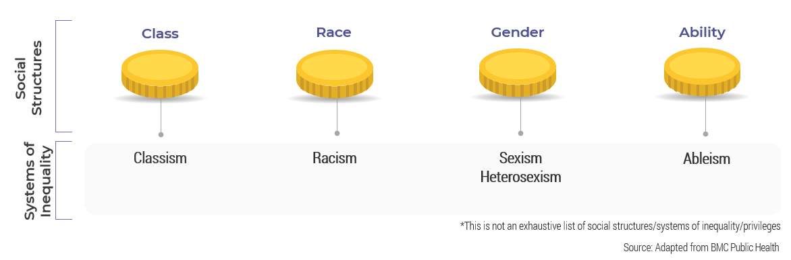

Defining social structures and systems of inequality
Class refers to both social and economic status. This looks at how much money people have and how much access they have to opportunities like education or jobs. Think of how the media represents social and economic status through celebrities or how society views doctors and lawyers compared to other professionals.
- Classism is discriminating based on these statuses. Common statuses include upper, middle, and lower class.
Race is a concept that refers to groups of people based on their physical attributes like skin color.
- Racism refers to discriminating against individuals who are not from the dominant race (i.e. not white) because of their skin color.
Gender must be looked at as identity and expression. Gender identity refers to socially constructed roles and behaviors. It is fluid and can often be an identifying characteristic of how individuals perceive themselves and others. Gender identity is how individuals experience and express their self-perceptions. For example, male-ness, female-ness, or non-binary. Gender expression is how an individual presents their perceived gender identity outwardly; for example, their preferred pronoun or how they choose to dress. A number of inequalities stem from gender
- Sexism is discriminating against individuals based on their gender identity. Consider leadership roles. Often gender roles are used against women to assume that they are not capable leaders.
- Heterosexism is prejudice and discrimination based on assuming that only male-female relationships are the norm and views individuals who are “straight” as superior. For example, often in children’s books, families are portrayed as mom, dad, and child.
Ableism is discrimination against people with disabilities and is manifested through cultural beliefs, attitudes, and assumptions that perceive them as inferior. Ableism is woven through social, economic, and political structures and perpetuates normalization of able-bodied discourse in such structures. Examples include inaccessible buildings and using discourse/terms like “climbing the corporate ladder” or “that’s crazy.”
Notes:

Allyship begins with recognizing your privilege and power

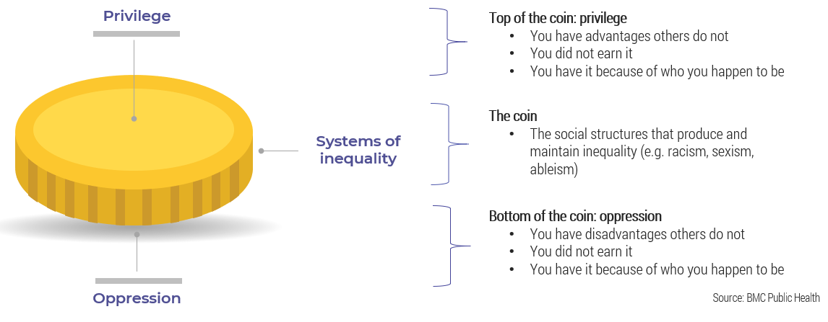

Privilege
Privilege refers to the unearned advantages that dominant or white groups hold, which is often unconscious. Privilege manifests itself in several ways in social, economic, and political circumstances and is woven through systems and institutions that operate today, even within our workplaces. Individuals who benefit from these social structures did nothing to earn the resulting “advantages,” but they still receive them.

Oppression
Oppression is the institutional and systemic use of power over a marginalized group to maintain status quo and inequality. In fact, such inequalities are woven through social, economic, and political structures through hierarchical relationships, cultural hegemony, and dominant discourse – in other words, in our everyday lives.
Notes:

Anyone can be an ally

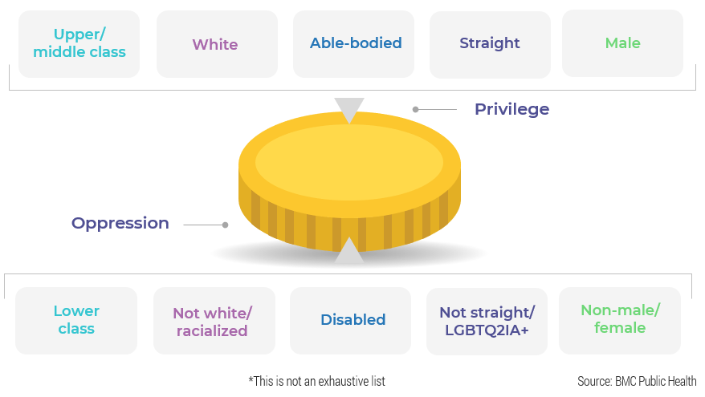

Definitions

Upper Class: A type of socioeconomic stratification that refers to individuals with the greatest extent of power and wealth in the larger society.

Middle Class: A type of socioeconomic stratification that refers to individuals who fall between upper and lower class. This category is largely composed of working professionals who have some power in society and have a reasonable amount of disposable income to make investments (i.e. owning property, luxuries like vacations, etc.).

Lower Class: A type of socioeconomic stratification that refers to those with the least amount of power and disposable income when compared to the larger society. Often, this category is referred to as the “working class.”

White: A racial classification/skin color of Caucasian individuals.

Racialized: Individuals who are not Caucasian and often face discrimination and systemic barriers owing to prejudices against their identified race. Often, the term is used interchangeably with “visible minority” and “people of color.”

Disabled: An individual or people who identify as having a disability.

Able-bodied: An individual or people who do not identify as having a disability.

Straight: Someone who identifies as heterosexual.

LGBTQ2IA+: An acronym for Lesbian, Gay, Bisexual, Transgender, Queer or Questioning, Two-Spirit, Intersex, Androgynous 1or Asexual, (+ includes Pansexual, Demisexual, etc.).

Male and Female: These terms are used to categorize sex, which refers to a set of biological and physiological attributes.

Notes:

Activity: Privilege Self-Assessment

Complete the self-assessment and reflect on the question at the end. Check off all the statements that apply to you.

- I have never been discriminated against because of my skin color.  - I have never been mocked for my accent.  - I have never been a victim of violence because of my race.  - I have never been called a racial slur.  - I have never tried to hide my sexuality.  - I have never been violently threatened because of my sexuality.  - I have never tried to change my gender.  - I have never been denied an opportunity because of my gender.  - I make more money than my professional counterparts of a different gender.  - I have never felt unsafe because of my gender.  - I work in a salaried job.  - I have never done my taxes myself.  - I have never had to worry about making rent.  - I have had multiple unpaid internships.  - I can afford private and/or higher-level education.  - My parents paid (at least some of) my tuition. | - I travel internationally at least once a year.  - I studied abroad.  - I do not have any physical disabilities/social disabilities/learning disabilities.  - I can afford medication if/when I need it.  - I have never been violently threatened or attacked for my religious beliefs.  - There is a place of worship for my religion in my town.  - I have never lied about my ethnicity as self-defense.  - All my jobs have been accommodating of my religious practices.  - I am not nervous in airport security lines.  - I have never been called a terrorist.  - I have never been cyberbullied for any of my identities or physical appearance.  - I was not bullied as a child for any of my identities.  - I have never tried to distance myself from any of my identities.  - I have never been self-conscious about or questioned any of my identities.
Reflection question: Have you ever considered any of the items you placed a checkmark beside as an advantage or disadvantage?

Some of these items may have surprised you. You may never have considered these privileges before. However, individuals who cannot check these boxes face real disadvantages. The objective of this activity is to highlight why it’s important to accept everyone the way they are and to think about how you can support and help each other.

Equip yourself to be an ally by learning key concepts

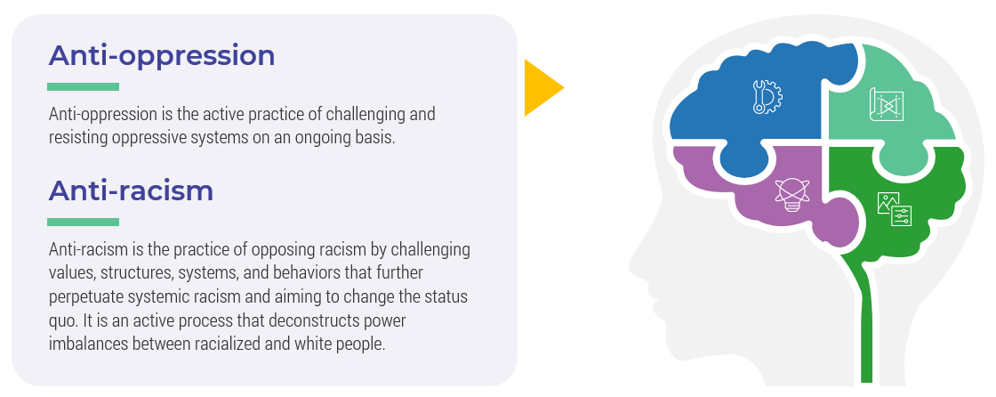
Notes:

What if I make a mistake?

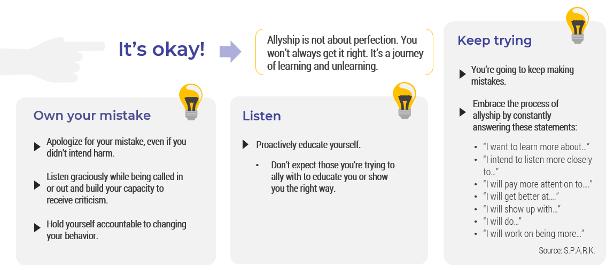

Notes:

Activity: What would you do?

As a group, select one or two scenarios and discuss how would you respond as an ally.

Scenario 1: A coworker on your team recently came out as trans and has shared their preferred name and pronouns. Another colleague on your team comes over to your desk and complains about how they don’t see the point of having to use the individual’s preferred pronouns and that they think it’s ridiculous to expect everyone to switch.

Scenario 2: Your organization has decided that Diversity, Equity, and Inclusion is a priority and has arranged a number of lunch and learns where speakers will share their experiences. A Black colleague shares that they are disappointed that none of selected speakers are Black, Indigenous, or People of Color and that the speaker slate is only made up of white women. When she brought up her concerns with some senior leaders and colleagues, she received feedback that she was too abrasive and that she should appreciate the organization’s efforts.

Scenario 3: Rhea has just returned from maternity leave. During a team meeting, your manager presents an opportunity for a new project that requires some travel. The project is within Rhea’s expertise and she would be an excellent candidate. However, you hear your manager say to her at the meeting, “Now that you have a baby, you probably won’t be interested in traveling for work.”

Scenario 4: Hasan suffers with anxiety and often struggles to speak up in social events or meetings. During a conversation you had with Hasan and another coworker, Hasan had a great idea to increase efficiency in the department. During a department-wide innovation event, everyone was asked to share their ideas. Because there were so many people at the event, Hasan felt even more anxious to share his idea. Instead, the other coworker shared Hasan’s idea without consent and was given credit for it.

Notes:

Allyship active behaviors

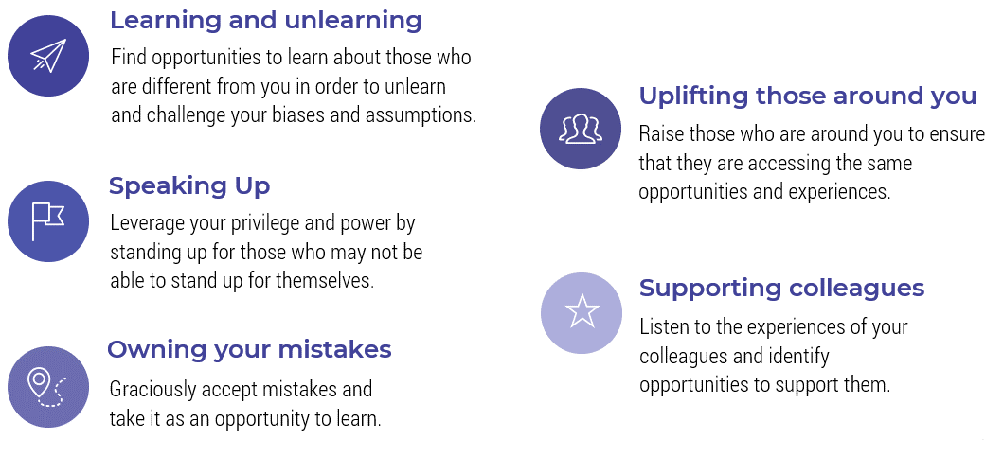

Notes:

Activity: Addressing uncomfortable situations as an ally

This is a two-part activity:

Part One

On your own, brainstorm three to five uncomfortable situations you have encountered in the workplace. It does not have to be this workplace; it could be a situation you have read about or experienced somewhere else.

Beside each situation, write down why the situation made you uncomfortable. Consider writing down why you had trouble addressing the situation.

Part Two

As a group, brainstorm ideas around how you can respond to the situations you’ve all identified.

Situation Why was it uncomfortable? Allyship tactics

Handle difficult conversations with EASE

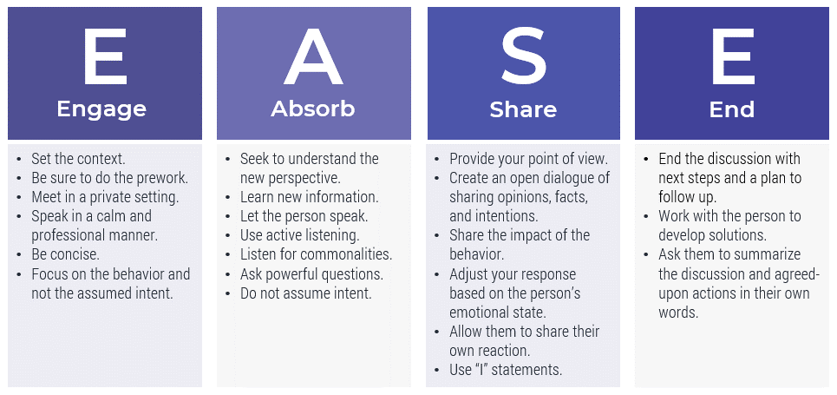

Notes:

Leverage empathy to support your colleagues
in the workplace

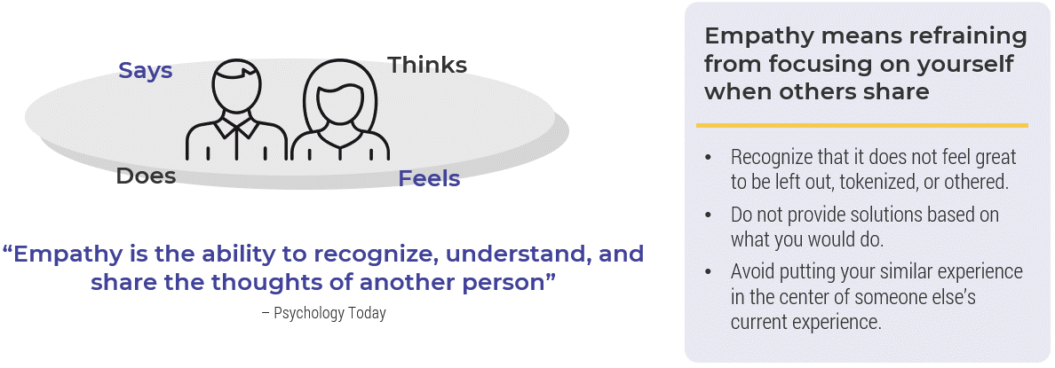

Notes:

Activity: Build your empathy map

Think of a time when you needed an ally and write that down below.

Once you’ve identified a situation, turn to your partner and take turns explaining to each other what happened.

As your partner explains their situation, write down:
- What did your partner say to the other person? Why did they not say?
- What were they thinking in the moment?
- What did they do or not do?
- How did they feel at this moment?

A time when I needed an ally:

Thinks
Says

User
Feels
Does

Sometimes, your support as an ally will be less obvious

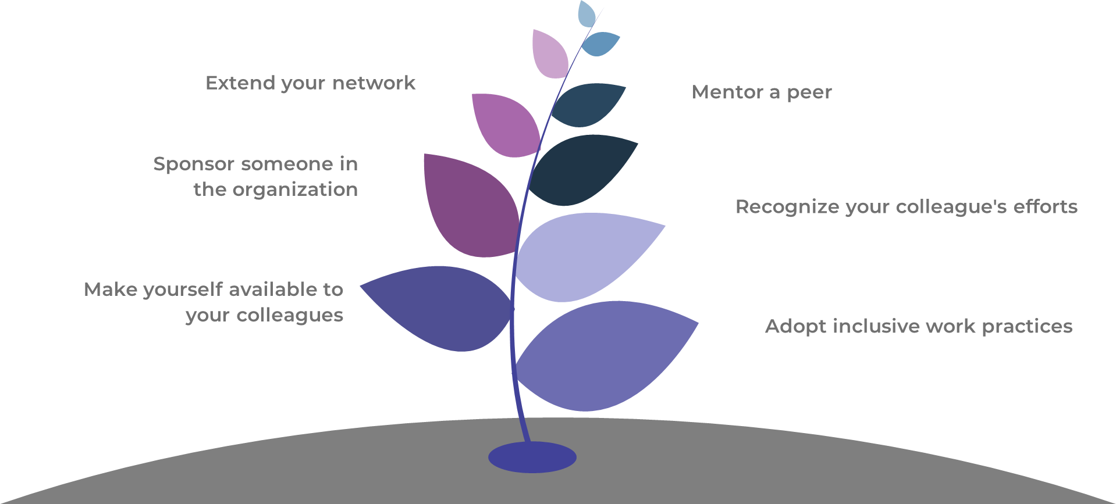

Notes:

Activity: How will you hold yourself accountable?

Think of what you want to be as an ally and identify some goals. Write them down in the space below.

Once you’ve identified your goals, share them with the larger group.

As you share, ask your colleagues for action items that will help you meet your allyship goals.

Goals: Action items:

_____________________________________________________

